Equation Solving Review

Determine the solution to each of the following equations.

**a)** 7*m* – 19  86 **b)** 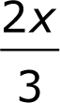  4  –2

**c)** 5,6*y*  3,2*y*  13,2 **d)** –4*w*  21  –7*w* – 15

**e)**  **f)** 