Course Objective/ Learning and Developmental Goals

This course aims to ensure that our students are numerate and embody mathematical habits of mind. It develops skills and processes citizens can use to critically analyze information encountered at work, in finances, and in daily life, while providing the fundamentals on which mathematical specialties and professional applications of mathematics are built. The aim is to develop deep mathematical understanding and fluency, logical reasoning, analytical thought, and creative thinking. Content focuses on concepts related to number sense, patterns and relations, spatial sense, and statistics and probability. Students are encouraged to take risks, experiment, and make logical guesses. They will experience both success and failure, ultimately learning perseverance while developing confidence and competency in mathematics.

In keeping with current curriculum developments, teaching strategies will encompass the model that students should:
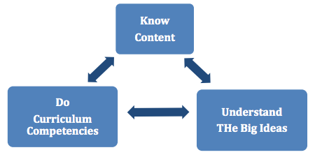
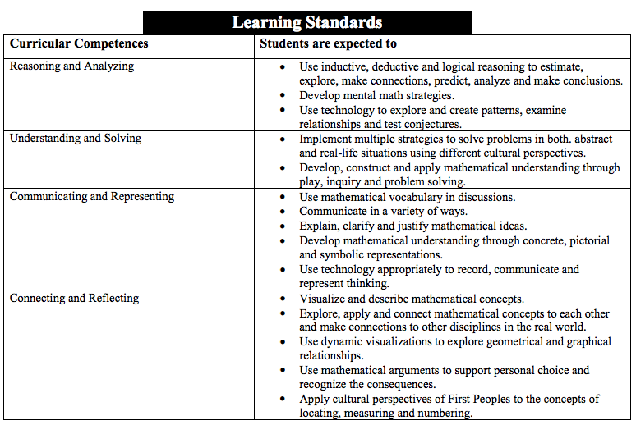
Units of Study
Les nombres rationnels (6 days)
Les puissances et les exposants (7 days + 2 days for a project)
Les facteurs d’échelle, la similarité et la trigonométrie (10 days)
Les polynômes (8 days)
Les relations linéaires (6 days)
La multiplication et la division des polynômes (8 days)
La resolution d’équations linéaires (10 days)
L’analyse des données (6 days)
Finances Personnels (5 days)

Assessment/grading

To complete the course successfully, a student is required to demonstrate a certain level of ability (Approaching Expectations) in all content areas as assessed in each of the four competencies at least three times. For example, in Financial Literacy, a student would be required to show, three times, their ability to “understand and solve” as described by the sub-categories above. In a similar manner, students are required to demonstrate their ability, three times, in the remaining three competencies. In total, a student would be required to show 12 samples of their abilities in Financial Literacy in a variety of ways. Each of these samples will be graded numerically on a four-point scale and scores that are produced most frequently and most recently will carry more weight toward a final score in the course. A course is considered incomplete and not eligible for credit until the entirety of the content has been covered in this manner.
Students will be assessed and evaluated through a variety of means to meet different learning styles. Students will engage in both individual and group activities to guide their learning. Students will have opportunities to self-evaluate their own learning and celebrate achievements. Students will be encouraged to engage in an environment that accepts and builds on individual strengths and challenges.
Homework can be expected daily and will be posted on my homework site, www.grottolieducation.weebly.com which can be accessed directly or through the school’s homework page at https://www.fhcollins.ca/homework.html. In order to avoid accumulating misconceptions, it is necessary for students to keep up with class expectations and homework. Certain lessons will require participation in class and cannot be replaced by online learning. As such, extended absences from class are not encouraged. However, in the event of such unexpected situations, the content will be made available through my homework page.
Formative and Summative assessment activities:
• Observations & Questioning
• Student Interviews
• Peer Assessment and discussions
• Self-Evaluation on content and core competencies.
• Oral Reports
• Concrete Representations
• Problem Solving
• Student Work
• Error Corrections
• Worksheets and Questions
• Discussion
• Quizzes and Tests
• Assignments and Project

More generally:
1. I Collect Evidence from Products and Observations to Use in Formative and Summative Judgments.
Ex: chapter summaries, team problem-solving
2. Students Are Involved in Co-Constructing Criteria in Instructionally Significant Areas.
Ex: discussions about how to present work
3. Students Give Specific and Descriptive Feedback to Themselves
Ex: answers keys provided for homework
4. Students Have Access to Samples of Quality.
Ex: examples in class
5. Students Give Specific and Descriptive Feedback to Others.
Ex: group work for homework or portfolio work
6. Students Set Specific Goals and Collect Evidence of Their Progress.
Ex: I know statements before tests

Discipline Plan I expect students to:
- Show respect to your classmates, your teacher and the material.
- Be in class on time with ALL your material, hence your calculator.
- Cell phones can’t replace your calculator and shouldn’t be seen in class. Administration will handle matters of cell phone misuse.

Course pre-requisites

None

Plan for Communicating with Parents

- On my homework website, parents and students will find all the lessons, the list of homework questions assigned and upcoming due dates.
- I send an interim report home (documenting student achievement and progress) with students before 3-way conferences. The document is to be signed and returned to me by the student.

- I call or email parents about attendance and, if a student is underachieving, to discuss plans of action for remediation.

Plan for Evaluating/Adjusting Long-Range Plans:
ongoing depending on students’ learning, assessment.

Resources- textbooks

Liens mathématiques 9, Chenelière McGraw-Hill
Mickelson Workbook

Classroom materials

Binder (1 ½in.)
Loose leaf (300)
Graph paper (50)
Dividers (4)
Pencils
Ruler
Graphing Calculator e.g TI83 (available at the library) - every day

